ADTA 5130 Data Analytics I

Analysis and Prediction on Cryptocurrencies

Group D

Eric Droegemeier

Gregory Ehlinger

Tejaskumar Patel

Brad Reese

According to the Oxford dictionary, cryptocurrency is “a digital currency in which transactions are verified and records maintained by a decentralized system using cryptography, rather than by a centralized authority.” Since its creation in 2009, the cryptocurrency industry has exploded, especially in the past few years, and reached an estimated market size of $2.2 trillion earlier this year. With the public awareness of the cryptocurrency market ever increasing, we wanted to analyze the performance of notable cryptocurrencies and compare their performances to the performances of investments commonly found in typical portfolios. Our target audience is open-minded investors who are willing to take on risk. We hope our analysis will assist these investors to determine whether or not cryptocurrencies should be considered as sound an investment as traditional ones. Thus, we have come to the following hypotheses:

**The Null Hypothesis:** Cryptocurrency are not correlated to traditional investment options such as stocks, gold, silver, and other commodities.

**The Alternative Hypothesis:** Cryptocurrency are correlated to traditional investment options and will be a sound investment option as a way of diversifying a portfolio that contains stocks, metals, or other coins.

In order to compare the performances, we pulled the spot price data on multiple metals, commodities, stock indexes and cryptocurrencies over the course of January 4th, 2016 to September 16, 2022. For cryptocurrencies, we looked at the performances of Bitcoin (BTC), Ethereum (ETH), Solana (SOL), Avalanche (AVAX), Cardano (ADA), Polkadot (DOT), Dogecoin (DOGE), Shiba Inu (SHIB), and UNISWAP. We have classified these cryptocurrencies into three groups: “Mature” consisting of Bitcoin, Ethereum, and Dogecoin; “Alternative” consisting of Solana, Avalanche, Polkadot, and Shiba Inu; and “Defi” consisting of Cardano and UNISWAP. For metals and commodities, we looked at the performances of silver, gold, crude oil, and wheat. And for stock indexes, we looked at the performances of FXIAX, S&P 500, Russell 3000, and NASDAQ. The datasets we observed include five-year comparisons for our initial correlation graphs and for the before and after analysis.

**Part I: The Current State of Cryptocurrency in Relation to Other Asset Classes**

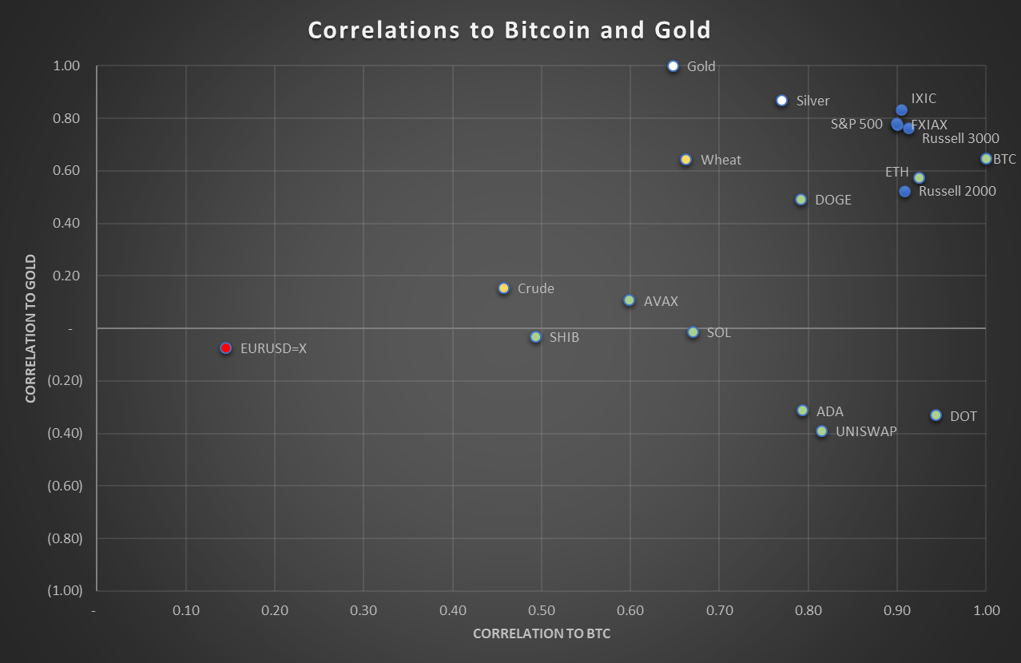

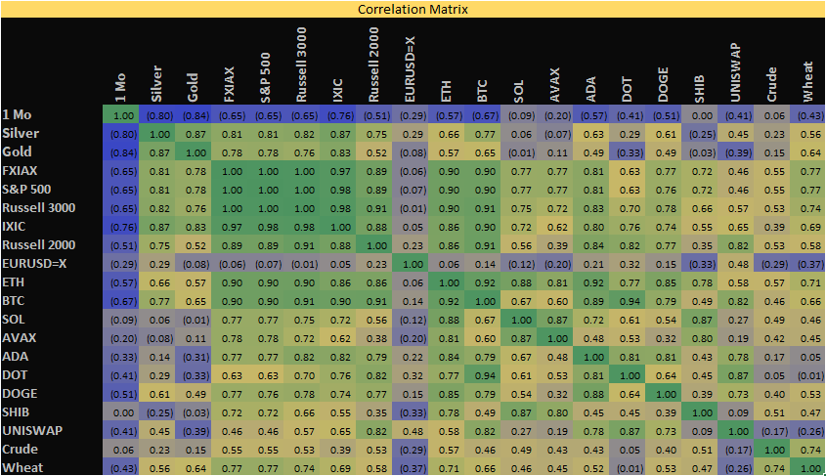

We have constructed the two graphs above measuring correlation; a correlation graph that compares the relationships an item has to gold and bitcoin (BTC) and a correlation matrix that measures the relationships between each item. When looking at the stock indexes, we noticed that FXIAX, S&P 500, Russell 3000, and NASDAQ are all highly related to each other with a correlation near or close to 1.00 meaning that as the price for one stock index increases/ decreases then the prices for the other stock indexes should react in the same direction. Mature cryptocurrencies such as Bitcoin and Ethereum also show to have a very strong and positive correlation nearing 0.90 to stock indexes. Additionally, mature cryptocurrencies seem to be positively related to precious metals and commodities. Alternative cryptocurrencies such as Solana and Avalanche do not have as strong a correlation to stock indexes compared to mature cryptocurrencies but alternatives have little to no relationship to precious metals. Defi cryptocurrencies such as Cardano and UNISWAP possess strong positive correlations to stock indexes; however, Defi cryptocurrencies have either little or negative correlation to precious metals and commodities. Based on these observations, any risk-seeking individual looking to further diversify their investment portfolio beyond that of metals and stocks should consider buying Mature cryptocurrencies since they produce similar value over time when compared to stock indexes.

**Part II: Which Market Sector Would Cryptocurrencies Occupy and When to Buy**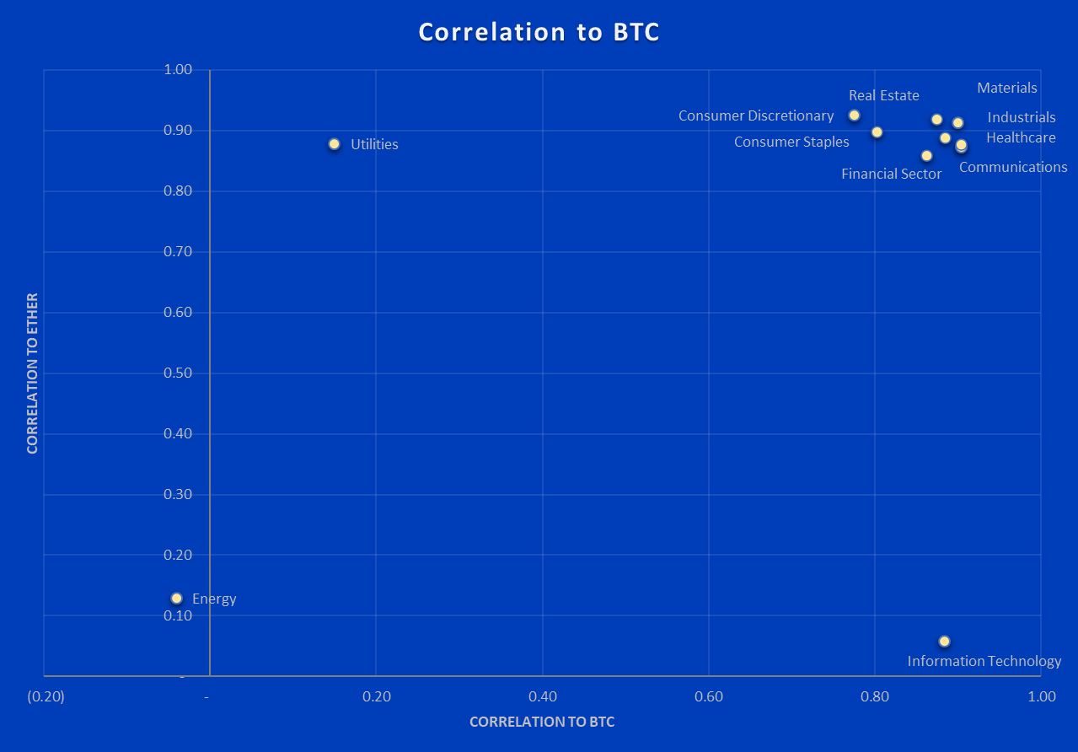

In order to better diversify stock options for investment portfolios, financial institutions have “sorted publicly traded companies into 11 sectors.” Based on the close relationship mature cryptocurrencies have to index funds, we conducted further analysis between mature cryptocurrencies and the 11 industry sectors to see which sector has the closest correlation. For this comparison, we used the largest two mature cryptocurrencies, Ethereum and Bitcoin, as measured by market cap to compare against the 11 industry sectors. Both Ethereum and Bitcoin have a high correlation to most sectors; however, surprisingly Ethereum has almost no correlation to the information technology sector. The sector with the highest correlation to both Ethereum and Bitcoin is materials. If we follow the pattern of when to invest in cryptocurrencies based on the cyclical investing graph below and based on this relationship, the time to invest is now. We are mid-stream with fed rate hikes, and assuming the hike schedule for 2023 remains unchanged, we are at the perfect time in regards to purchasing cryptocurrencies. The federal interest rate is currently at 3.75% and it has been forecasted to increase rates 0.25% in March 2023 and then an additional 0.50% in May 2023. This would be holding below the threshold of 5.00%; however, if the fed rate were to hike two more times by 0.50%, then we will be at a federal interest rate of 4.75%. Any additional hikes should prompt us to sell crypto. This would likely come in June of 2023.

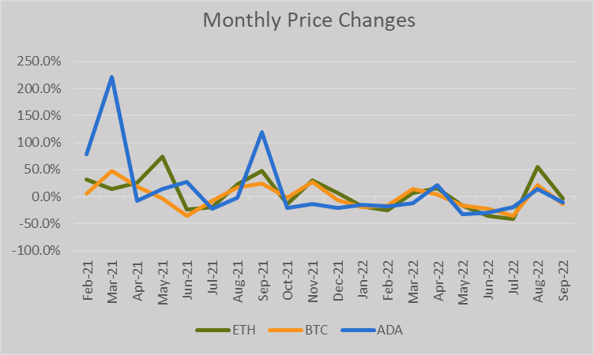

Additionally, we have observed the month-to-month changes in Bitcoin, Ethereum, and Cardano. As we can see, all three cryptocurrencies have been experiencing negative or stagnate growth over the past year. So, with prices low now and with the insights from the cyclical investing model, it would be a great opportunity to buy low and eventually sell high.

**Part III: Has cryptocurrency Replaced Gold as a Store of Value in Uncertain Times**

Gold has always been the quintessential benchmark or base unit for currencies; thus, why the phrase “the gold standard” exists. We wanted to compare if the emergence of cryptocurrencies has already or has the possibility to dethrone gold as the base unit of value.

We approached this by conducting a matched-pairs experiment taking data from before and after cryptocurrencies became well known. For our analysis, we used January 1, 2017 as the arbitrary date for when cryptocurrencies became well known. Thus, we created the “before” dataset to consist of samples taken from 2002 to 2016 and created the “after” dataset to consist of samples taken from 2017 to 2022. The key variables we looked at included inflation, unemployment, crude, US GDP, 10 year treasury yield, Silver, Russell 3000 and the M2 Money Supply. The values in the columns 2002 - 2016 and 2017 - 2022 represent the correlations to each metric in comparison to gold. Correlations in the column labeled “Before 2017” represent how gold was correlated to these different metrics before cryptocurrency became well known. Our null hypothesis in this scenario is that gold’s correlation to these different metrics has not changed while our alternative hypothesis is that the correlation to gold since 2017 has changed in comparison to before 2017.

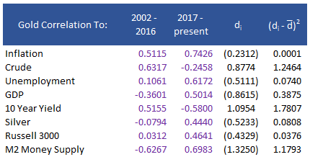

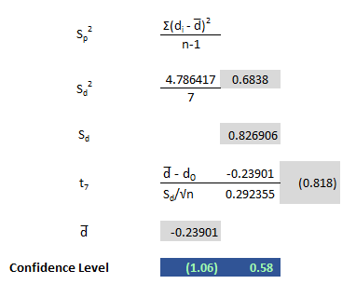

Based on our analysis we can conclude that cryptocurrency has not currently replaced gold as a store of value.

In regards to if cryptocurrencies can replace gold as a store of value, the future is too unpredictable to determine an answer. From a technology adoption standpoint, we can ascertain that cryptocurrency is still in the early adoption phase having first been launched in 2009. Last year in 2021, El Salvador became the first country to accept Bitcoin as legal tender while several companies in the S&P 500 have also accepted various cryptocurrencies as a form of payment. It is expected that the next countries who will adopt cryptocurrencies as legal tender will be countries with developing countries such as those in Africa or countries experiencing high inflation like Türkiye. Due to hyperinflation, the security risk of carrying physical money, countries like Zimbabwe, Kenya, and Uganda have a large portion of their population conduct money transfer on their phones; so, cryptocurrency experts see quick adoption as a high possibility. If we assume that mature cryptocurrencies like Bitcoin, Ethereum, and Dogecoin will eventually replace fiat currency in the United States, then the value of the current crypt market of $850B would need to increase to $22T.

**Part IV: Selecting the Best Regression Model to Predict the Price of Bitcoin**

We ran multiple regression models to find the best fit. The variables we included were four macroeconomic variables (inflation, unemployment, GDP and M2 money supply) along with gold and crude. The best goodness of fit for our models was model 2, where we removed gold and crude from the inputs. The P-Values were reasonable, with inflation being moderately high at 0.1351. We chose to keep inflation as Bitcoin is deflationary, and we expect it to correlate more closely with inflation. Inflation, GDP, and Unemployment are all based on percentages. For example, a 1% increase in inflation would result in a $2,541 increase in the price of Bitcoin. (.01 * 254,127) M2 Money Supply (labeled M2) is listed in billions of dollars. Thus, for every $1TN increase in the M2 Money Supply, there is a $6,130 increase in the price of Bitcoin. The adjusted R2 for model two is decidedly better than the other models.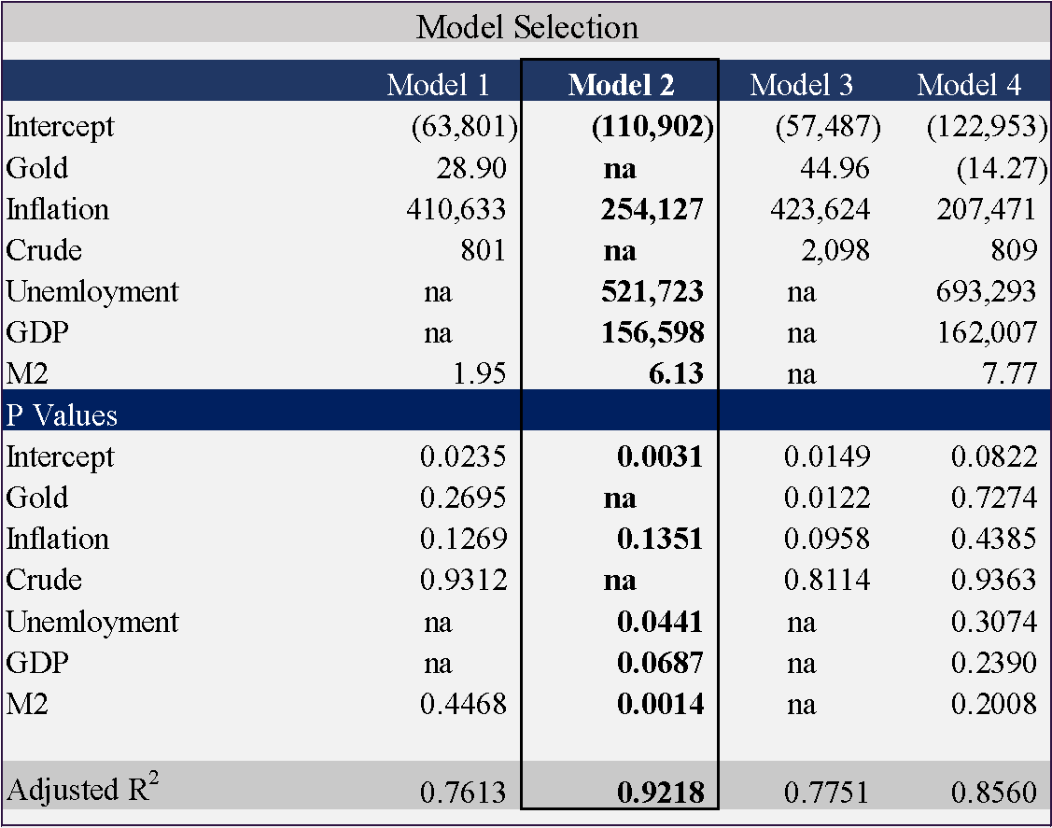

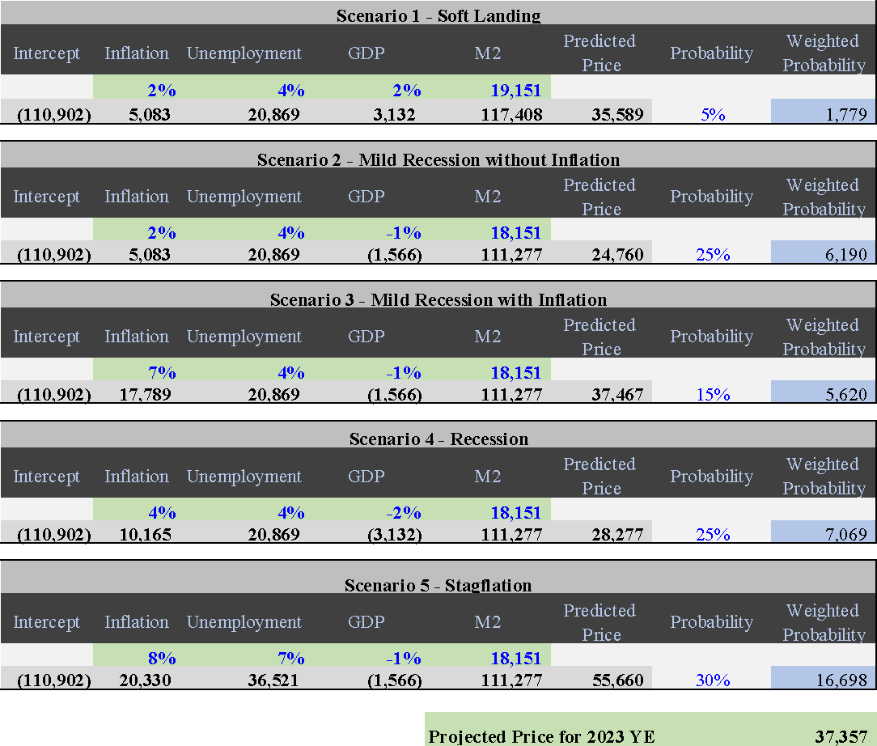

We combined the regression model with subjective probabilities on different economic outcomes for 2023 to project the price of Bitcoin at year end. We selected five mutually exclusive scenarios starting with a “soft landing” all the way to full stagflation. In each scenario we changed inflation, unemployment and GDP. M2 Money Supply remained unchanged, although the model can account for it if needed. We combined the intercept with the outcomes of those variables to get a predicted price for each scenario. Interestingly, the price increases the most in scenarios 3 and 5 where Inflation is higher. For each scenario, we have selected a subjective probability with the total probability of one of the five scenarios happening is equal to one. The last column is the weighted probability, where we can calculate the projected price of Bitcoin for year end 2023 of $37,357.

**Step V: Recommendations & Conclusion**

We have concluded that based on our data and studies that will be a sound investment option as a way of diversifying a portfolio that contains stocks, metals, or other coins. Specifically Mature cryptocurrencies like Bitcoin and Ethereum would be the soundest investment. With now being the time to invest in cryptocurrencies based on their close correlation to the materials sector and inflation increasing, we expect Bitcoin to not only hold its value but surge to a price of $37,357 by the end of 2023. With these conclusions, we recommend investors to stay current with the cryptocurrency markets and several on-shore exchanges such as Coinbase, Kraken, and Crypto.com. Investors should pay attention to major developments such as Fidelity releasing its own cryptocurrency platform or any government regulation. Lastly, we recommend taking some courses to be familiar with the cryptocurrency market such as the complete cryptocurrency course by Chris Haroun on Udemy. We hope investors can use our report with their decision-making with their investment portfolios.

Works Cited

Bureau of Economic Analysis. “Gross Domestic Product | U.S. Bureau of Economic Analysis (BEA).” *Bea.gov*, 2021, www.bea.gov/data/gdp/gross-domestic-product.

“Crypto Real Time Prices & Latest News - Yahoo Finance.” *Finance.yahoo.com*, finance.yahoo.com/crypto/. Accessed 10 Dec. 2022.

“Cryptocurrency Noun - Definition, Pictures, Pronunciation and Usage Notes | Oxford Advanced Learner’s Dictionary at OxfordLearnersDictionaries.com.” *Oxfordlearnersdictionaries.com*, 2022, www.oxfordlearnersdictionaries.com/definition/english/cryptocurrency#:~:text=Definition%20of%20cryptocurrency%20noun%20from%20the%20Oxford%20Advanced. Accessed 10 Dec. 2022.

“Current Employment Statistics - CES (National) : U.S. Bureau of Labor Statistics.” *Bls.gov*, 6 Dec. 2019, www.bls.gov/ces/.

Federal Reserve. “Federal Reserve Board - Home.” *Federalreserve.gov*, 2019, www.federalreserve.gov/.

Hwang, Inyoung. “Top 30 Cryptocurrencies (Based on Market Cap).” *SoFi*, 20 Sept. 2022, www.sofi.com/learn/content/top-cryptocurrency-market-cap/.

Namicos. “BitMEX CEO: Five Countries Will Accept Bitcoin as Legal Tender by the End of 2022.” *Nasdaq.com*, 2022, www.nasdaq.com/articles/bitmex-ceo%3A-five-countries-will-accept-bitcoin-as-legal-tender-by-the-end-of-2022-2021-10. Accessed 11 Dec. 2022.

Sawe, Benjamin Elisha. “The Use of Cell Phones to Transfer Money in Modern Africa.” *WorldAtlas*, 17 Aug. 2018, www.worldatlas.com/articles/the-use-of-cell-phones-to-transfer-money-in-modern-africa.html.

“Sector Rotation Cyclicals.” *Sectormarketwatch.com*, sectormarketwatch.com/cyclicals.htm. Accessed 10 Dec. 2022.

“The S&P Sectors.” *Corporate Finance Institute*, corporatefinanceinstitute.com/resources/valuation/the-sp-sectors/.

Yahoo Finance. “Yahoo Finance - Business Finance, Stock Market, Quotes, News.” *Yahoo Finance*, 2022, finance.yahoo.com/.